

**FACULTY OF COMPUTING AND INFORMATICS**

**CSE6224 – SOFTWARE REQUIREMENTS ENG**

**GROUP: G07**

**SESSION: TT4L**

**PROJECT REPORT**

|  |  |
| --- | --- |
| **Student Name** | **Student ID** |
| Yang Jia En | 242UC2451Q |
| Teoh Xuan Xuan | 242UC2451P |
| Tey Jun Cheng | 242UC2452Z |

**Submitted to: Dr. Zarina binti Che Embi**

**Date: 25 May 2025**

# Table of Contents

Table of Contents 2

1.0 Elicitation Execution Sessions 3

1.1 Brainstorming 3

1.1.1 Brainstorming: Output 3

1.1.2 Brainstorming: Proof of Elicitation 4

1.2 Surveys and Questionnaires 5

1.2.1 Questionnaire: Output 5

1.2.1 Questionnaire: Proof of Elicitation 7

1.3 Interview 16

1.3.1 Interview: Output 16

1.3.2 Interview: Proof of Elicitation 17

1.4 Prototyping 18

1.4.1 Prototyping: Output 18

1.4.2 Prototyping: Proof of Elicitation 19

1.5 Perspective-Based Reading 25

1.5.1 Perspective-Based Reading: Output 25

1.5.2 Perspective-Based Reading: Proof of Elicitation 26

1.6 Summary 26

2.0 Requirements Categorization 27

2.1 Requirements Categorization Table 27

2.2 Analysis 28

3.0 Conclusion 30

Change Log Table 31

# 1.0 Elicitation Execution Sessions

## 1.1 Brainstorming

### 1.1.1 Brainstorming: Output

A brainstorming session was conducted among the project team to identify initial system requirements for the university portal. The aim was to explore user needs across different roles (students, lecturers, parents, and administrators), align the team’s assumptions, and propose key features for deeper investigation during stakeholder interactions.

This internal session provided a structured environment for idea generation and helped define the scope of elicitation for the remaining techniques.

Activity details:

* Total of 3 members from the project team
* Duration: 45 minutes
* Platform: Microsoft Teams (online session)

Key Outcomes:

* Identified core stakeholder groups: students, lecturers, parents, admins
* Highlighted pain points in existing university systems:
* Complicated login process (e.g., lack of "Remember Me" function)
* Delayed access to announcements and exam timetables
* Manual classroom booking via in-person requests or emails
* No SMS notifications for urgent updates (e.g., tuition fees payment reminder)

Proposed system features:

* Student, parent, lecturer, and admin portals with role-based access
* SMS notification integration for announcements and billing
* Online classroom booking system with approval flow
* Grade, billing, timetable, and attendance viewing modules
* Prioritized user-friendly UI and accessibility features

### 1.1.2 Brainstorming: Proof of Elicitation

### 

Figure 1.1.2.1: Discussing with our team members

# 1.2 Surveys and Questionnaires

### 1.2.1 Questionnaire: Output

To validate and quantify the needs identified during brainstorming and interviews, a structured questionnaire was designed and distributed to stakeholders from different user roles in the university, including students, lecturers, parents, and admins. The questionnaire was aimed at classifying functional expectations using the Kano model and identifying opportunities for improving the university portal.

Distribution Method:

* Google Forms shared via class groups, faculty WhatsApp channels, and email
* Duration: 5 days
* Total responses: 25+ from mixed stakeholder groups

Structure:

* Over 30 structured questions including Kano-style paired questions
* Role-based routing (students, lecturers, parents, admins)
* Combination of Likert scale, multiple choice, and open-ended items

Topics Covered:

* Student Portal Use:
  + Login & session preferences
  + Viewing attendance, grades, billing info, announcements, timetables
  + Classroom booking and feedback mechanisms
* Lecturer Module:
  + Uploading materials
  + Scheduling assessments
  + Sending announcements
* Admin Tools:
  + Managing student inquiries
  + Mass communication and dashboard features
* Parent Access:
  + SMS notification preferences for grades, billing, and attendance
* General:
  + Preferred notification methods
  + Desire for help/support section
  + Suggestions for feature improvements

### 1.2.1 Questionnaire: Proof of Elicitation

Sample Questions:

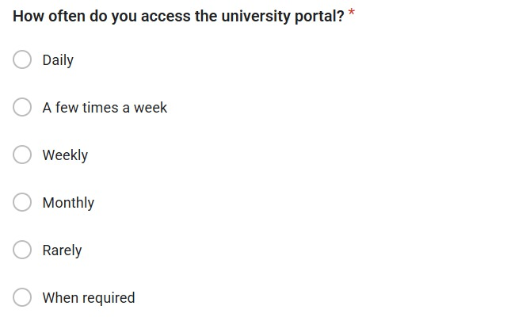

Figure 1: General Question 1

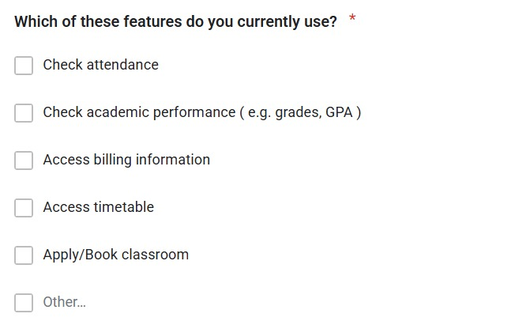

Figure 2: Student Question 1

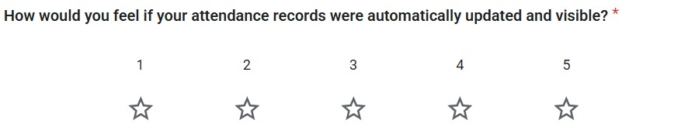

*Figure 3: Student Question 2*

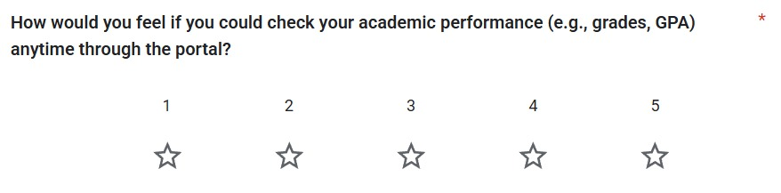

Figure 4: Student Question 3

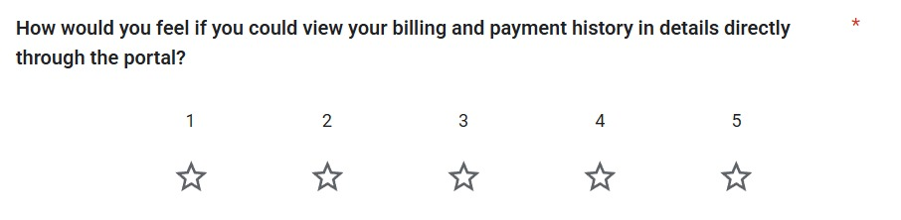

Figure 5: Student Question 4

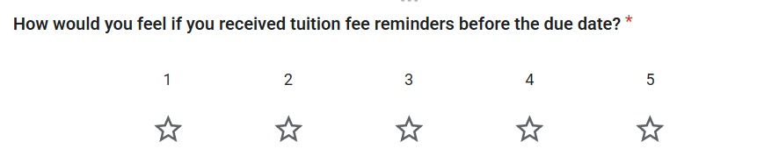

Figure 6: Student Question 5

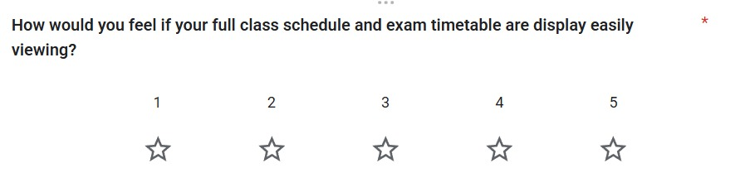

Figure 7: Student Question 6

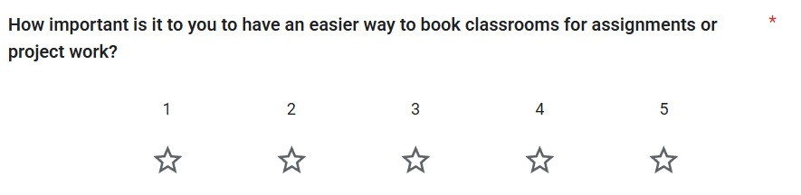

Figure 8: Student Question 7

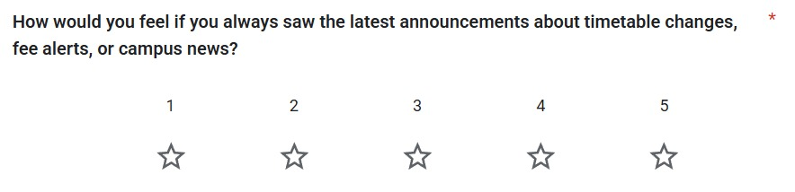

Figure 9: Student Question 8

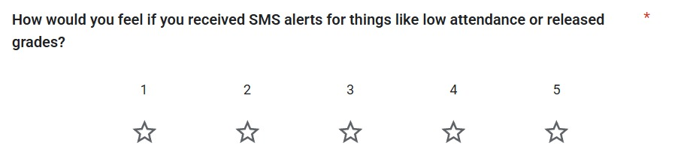

Figure 10: Student Question 9

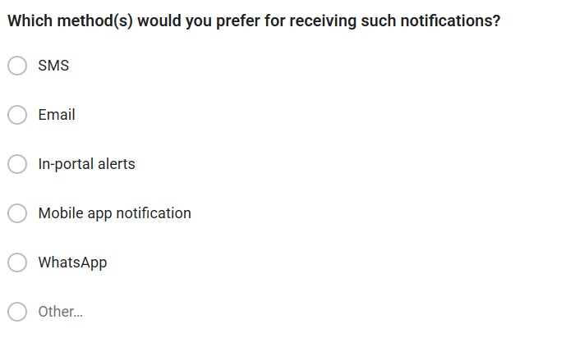

Figure 11: Student Question 10

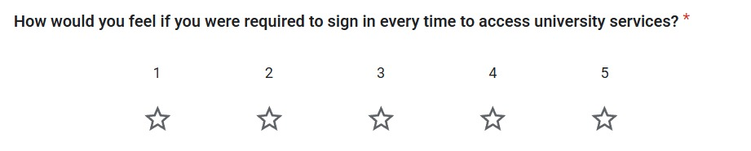

Figure 12: Student Question 11

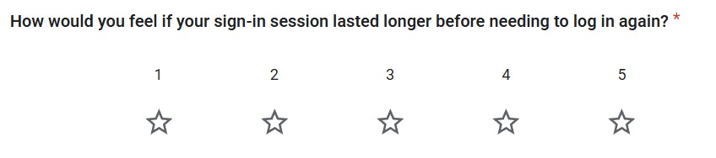

Figure 13: Student Question 12

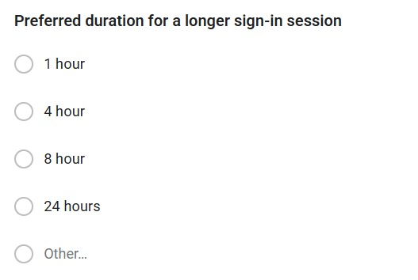

Figure 14: Student Question 13

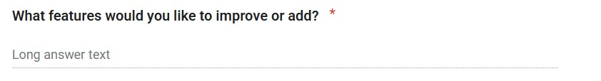

Figure 15: General Question 2

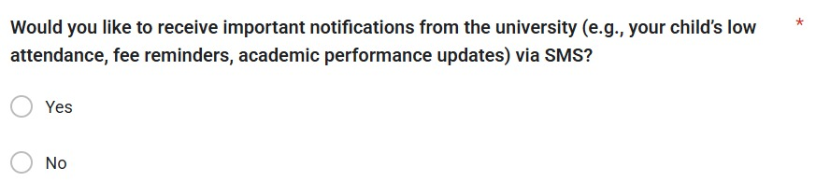

Figure 16: Parent Question 1

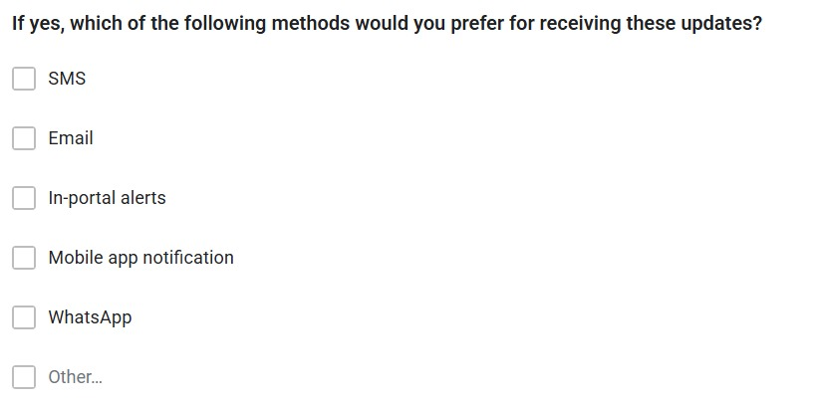

Figure 17: Parent Question 2

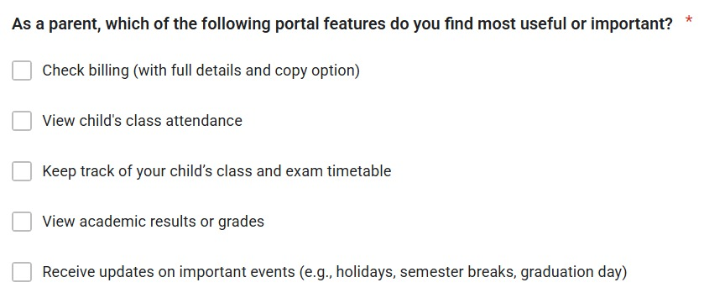

Figure 18: Parent Queston 3

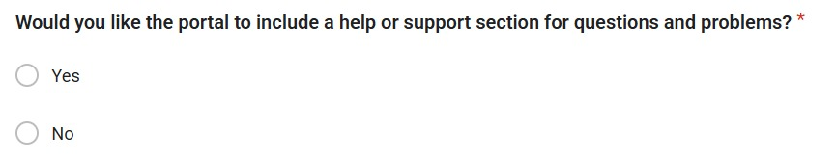

Figure 19: Parent Question 4

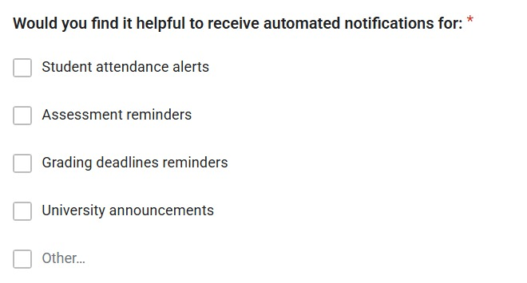

*Figure 20: Lecturer Question 1*

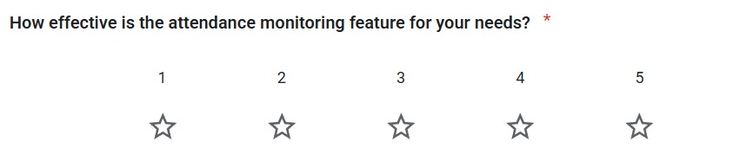

*Figure 21: Lecturer Question 2*

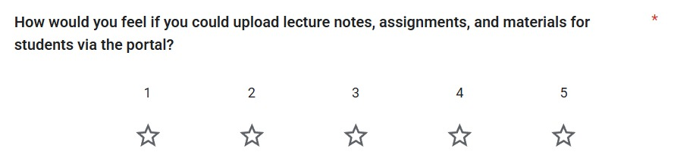

*Figure 22: Lecturer Question 3*

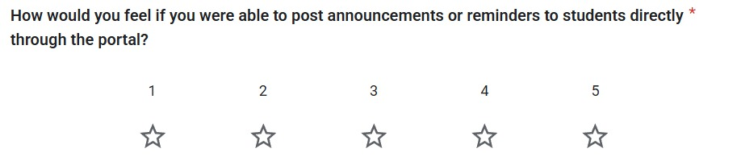

*Figure 23: Lecturer Question 4*

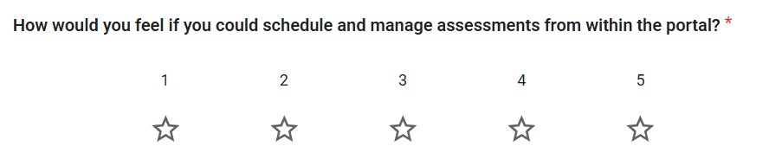

*Figure 24: Lecturer Question 5*

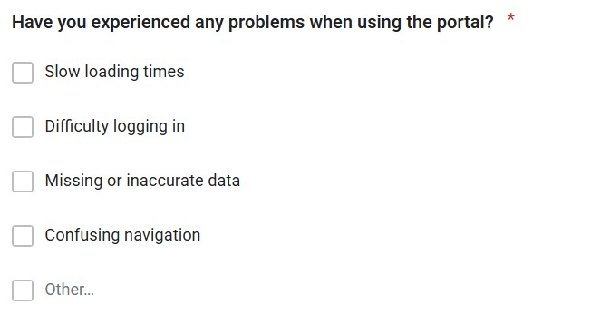

*Figure 25: Lecturer Question 6*

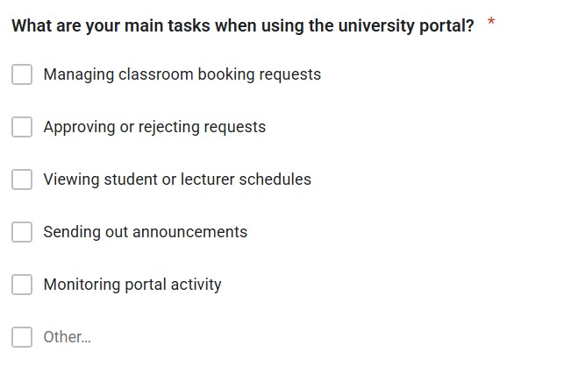

*Figure 26: Admin Question 1*

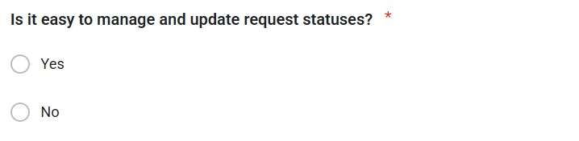

*Figure 27: Admin Question 2*

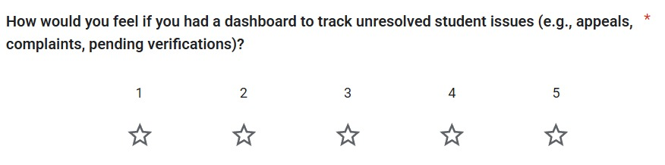

*Figure 28: Admin Question 3*

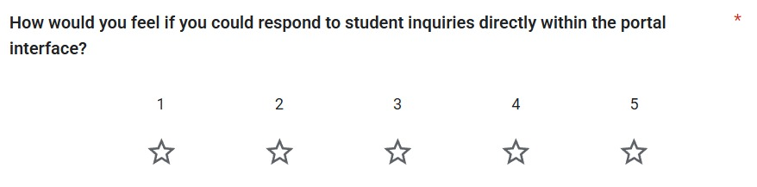

*Figure 29: Admin Question 4*

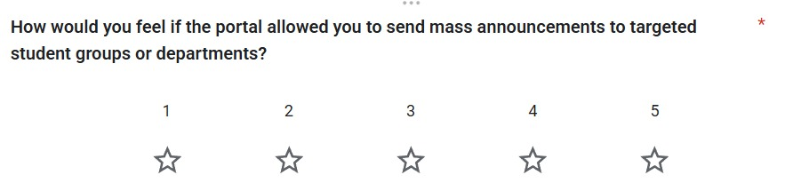

*Figure 30: Admin Question 5*

Link to the google form:

<https://forms.gle/LS5xtSN9gfYDV6X67>

## 1.3 Interview

### 1.3.1 Interview: Output

To gather qualitative insights, a short one-on-one interview was conducted with a student stakeholder to better understand day-to-day usage and challenges of the current university portal. The focus was on identifying functional pain points and evaluating the appeal of potential new features through a Kano-style question set.

Activity details:

* Participant: 1 university student (Participant 01)
* Role: Active portal user (student)
* Duration: ~5 minutes
* Platform: Voice recording (audio only – participant preferred not to appear on camera)

Key Findings:

* The current portal is mainly used for bill payments, academic records, timetables, and announcements.
* Logging in is often frustrating due to frequent OTP prompts and slow loading speeds.

The student suggested the addition of:

* A “remember me” login option
* Confirmation emails after fee payments

Highly valued features:

* Centralized dashboard for attendance, results, and fee tracking
* SMS alerts for deadlines or released results
* Clear display of class and exam timetables

Delighter Suggestion:

* Ability to buy MMU parking stickers online instead of queuing at a physical building

### 1.3.2 Interview: Proof of Elicitation

Interview was recorded via voice note.

Link to the interview:

<https://drive.google.com/file/d/11id5Mvk2kyyic8F7EqLziCZ_IXjenjQ3/view?usp=sharing>

## 1.4 Prototyping

### 1.4.1 Prototyping: Output

To validate the usability and layout of the University Communication and Services Portal, a set of low-fidelity prototypes was created targeting the student user role. The goal was to visualize key interfaces, test navigation flow, and gather preliminary feedback on feature accessibility and clarity before development.

The prototypes were designed using Figma and focused on core pages that reflect the main use cases for students.

Pages Developed:

* Login Page – Secure sign-in interface with fields for MMU credentials
* Dashboard Page – Centralized summary of announcements, grades, timetable, and quick links
* View Grades Page – Tabular format of course results with GPA summary
* View Attendance Page – Attendance breakdown by course with absence alerts
* View Timetable Page – Weekly calendar view with filters for class and exam schedules
* View Billing Info Page – Overview of payment history, upcoming dues, and receipt downloads
* Book Classroom Page – Booking form with date/time picker and facility options
* View Announcements Page – Feed of campus-wide notices and academic updates

Activity details:

* Platform: Figma
* Duration: 3 days of design iterations
* Reviewers: Internal project team and two student testers
* Feedback method: Verbal walkthrough and comment pins in Figma

Key Feedback Highlights:

* Navigation was intuitive; testers liked the clean layout and role-based flow
* Suggested adding filters for announcements (e.g., urgent, academic, billing)
* Recommended that booking confirmation appears immediately after submission
* Interest in a color-coded timetable to separate lectures and assessments

### 1.4.2 Prototyping: Proof of Elicitation

Below are the screenshots of all Figma pages.

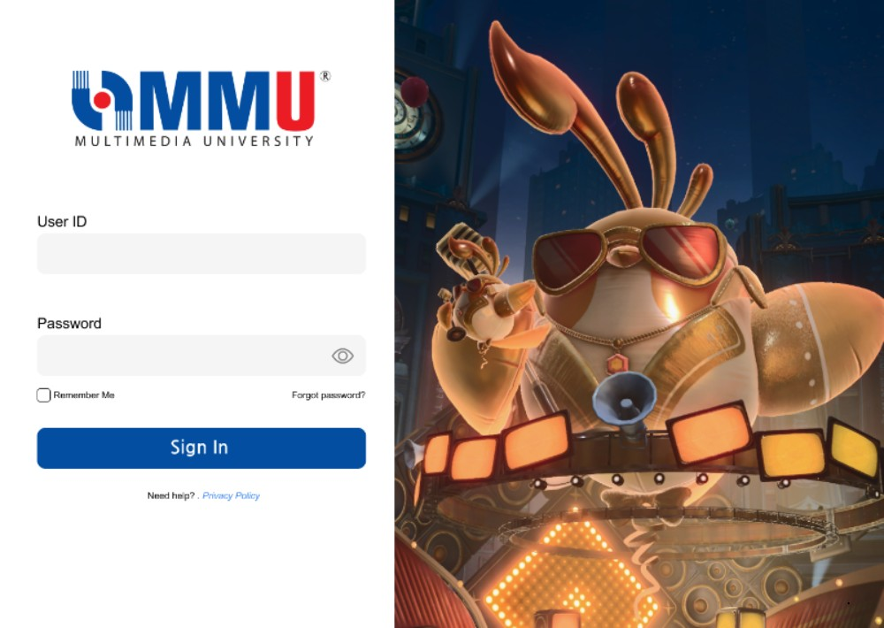

*Figure 31: User Log In Page*

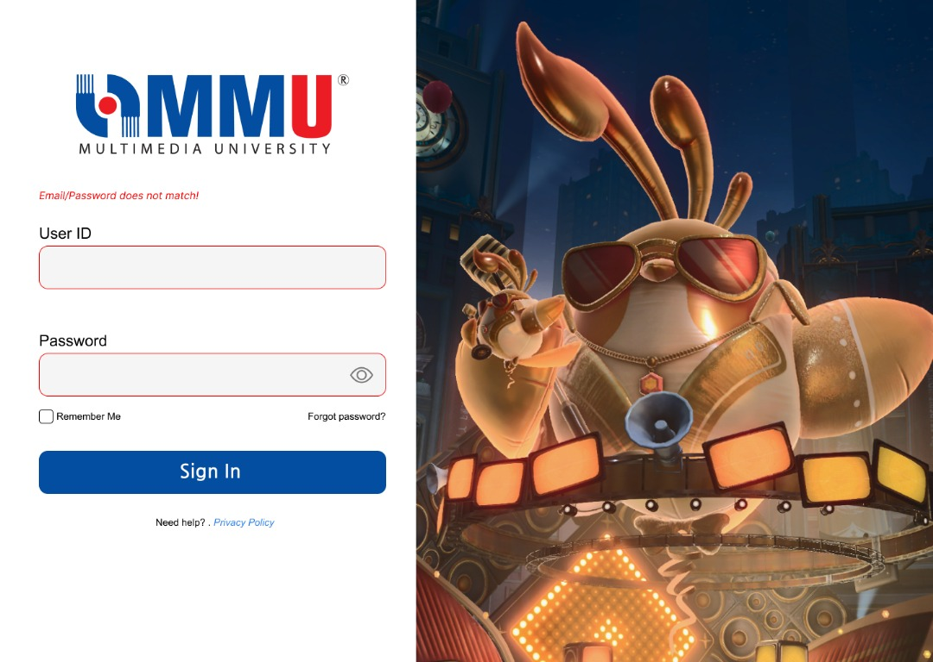

*Figure 32: User Log In Page with Error Message*

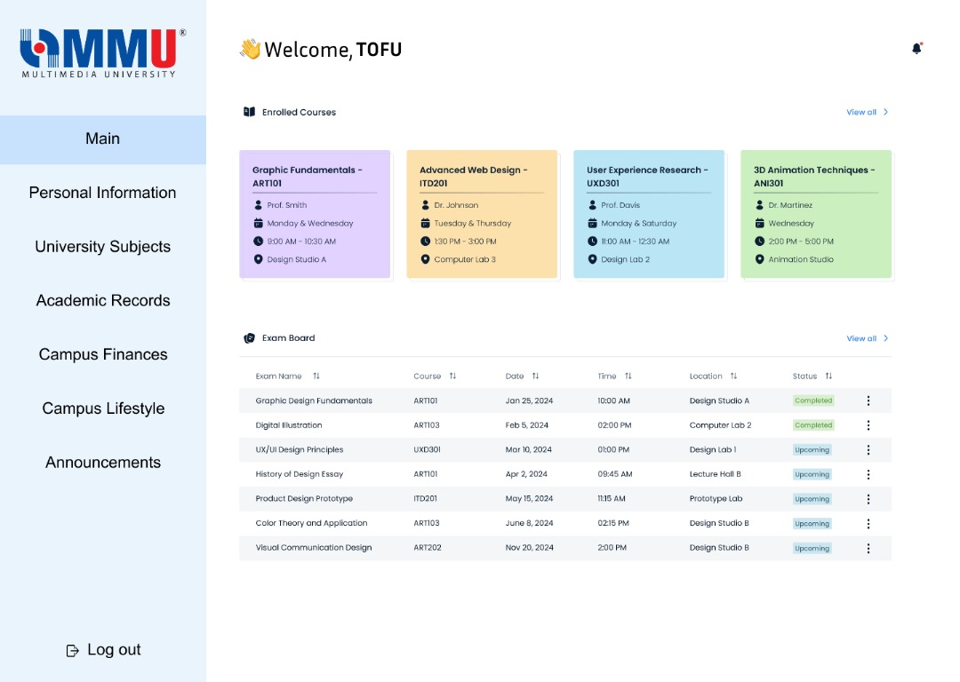

*Figure 33: Student Dashboard Page*

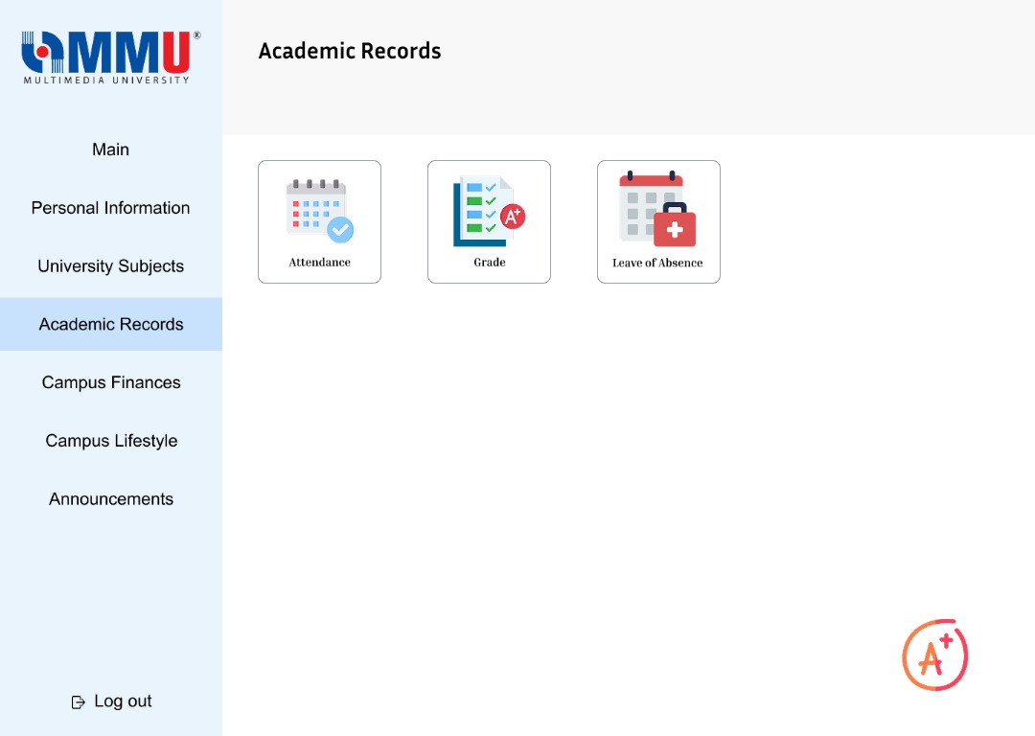

*Figure 34: Student View Academic Records Page*

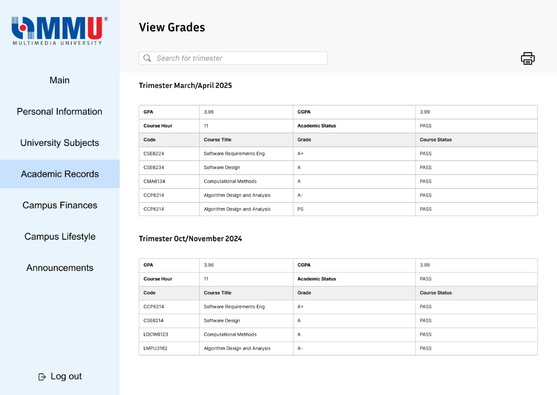

*Figure 35: Student View Grades Page*

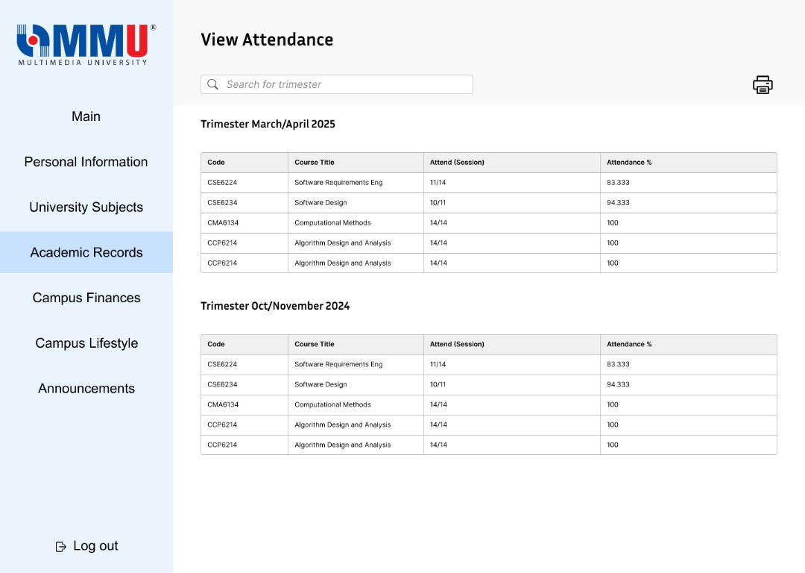

*Figure 36: Student View Attendance Page*

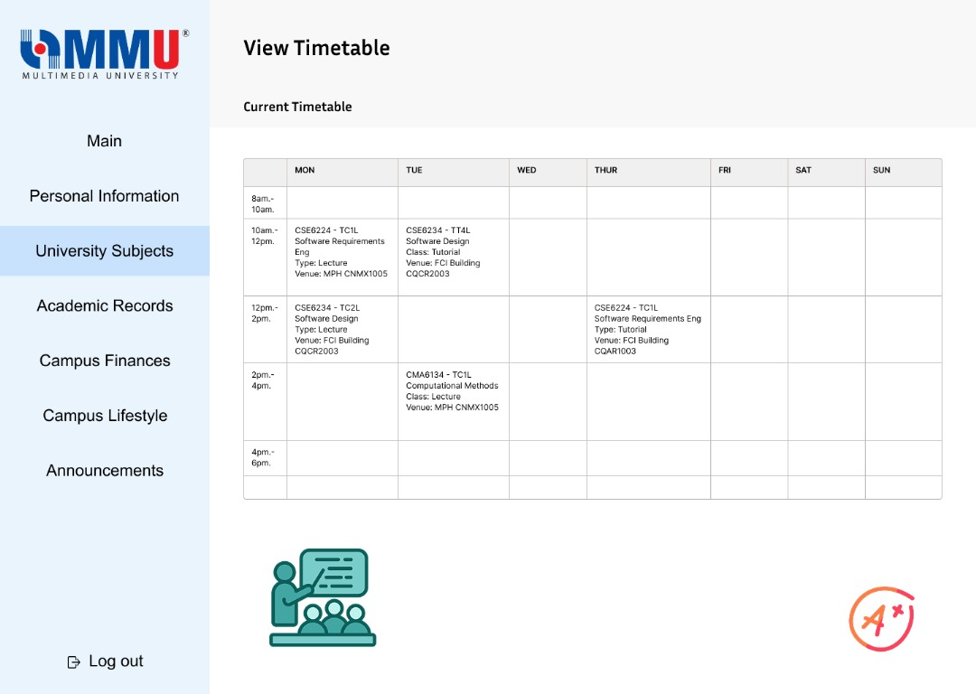

*Figure 37: Student View Attendance Page*

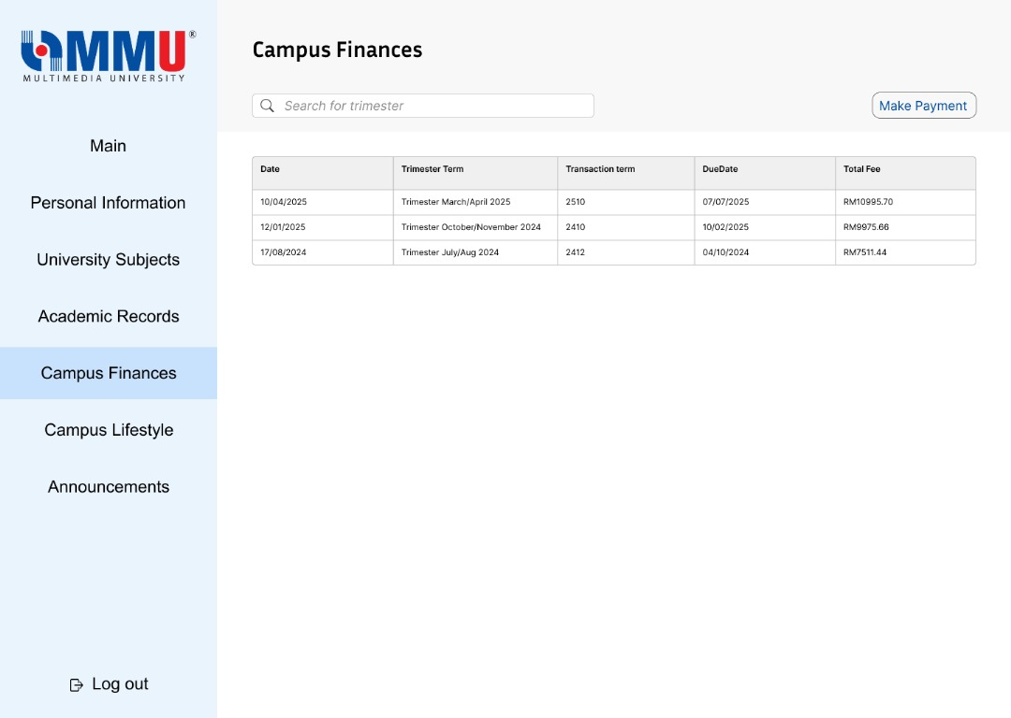

*Figure 38: Student View Billing Page 1*

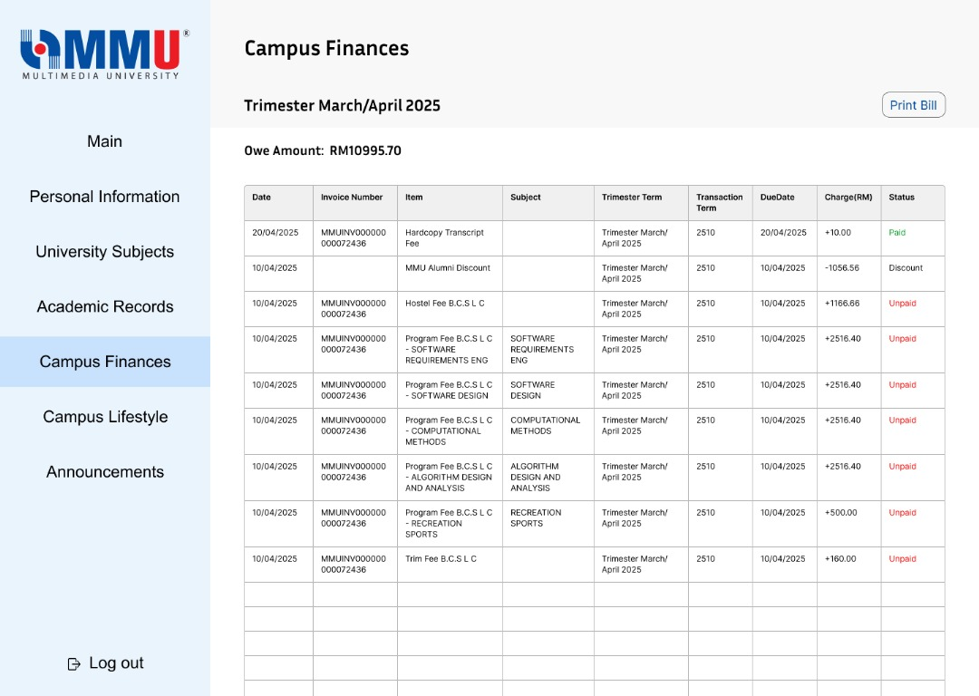

*Figure 39: Student View Billing Page 2*

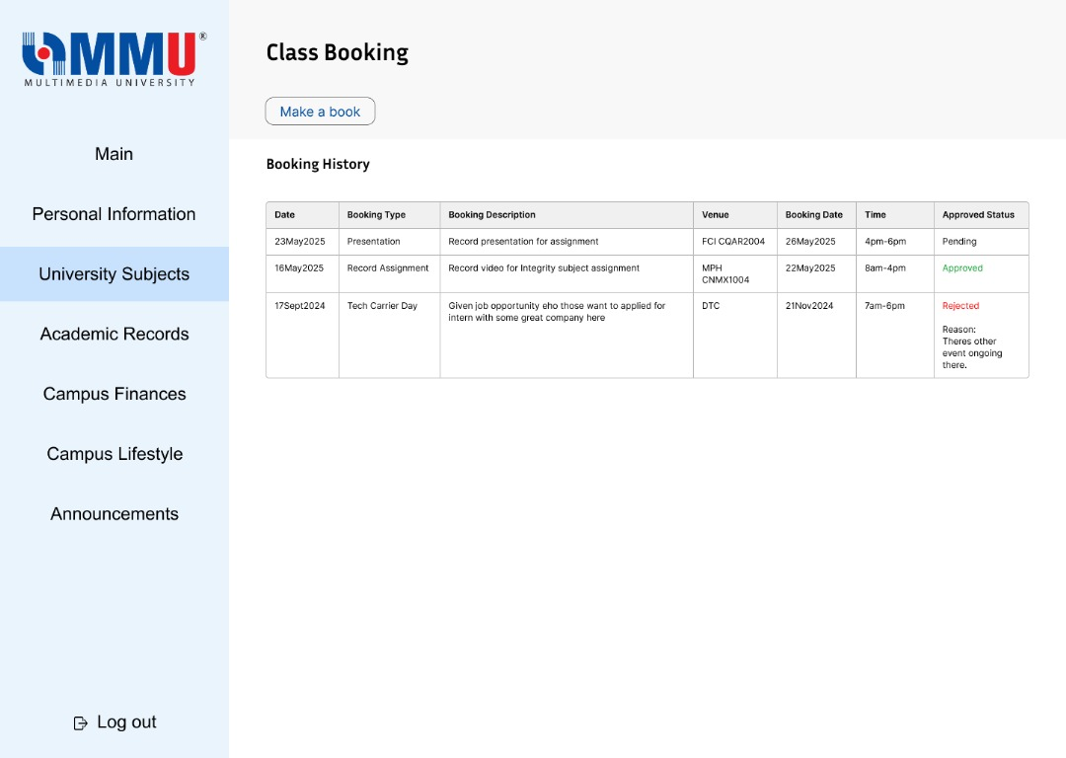

*Figure 40: Student Book Class Page*

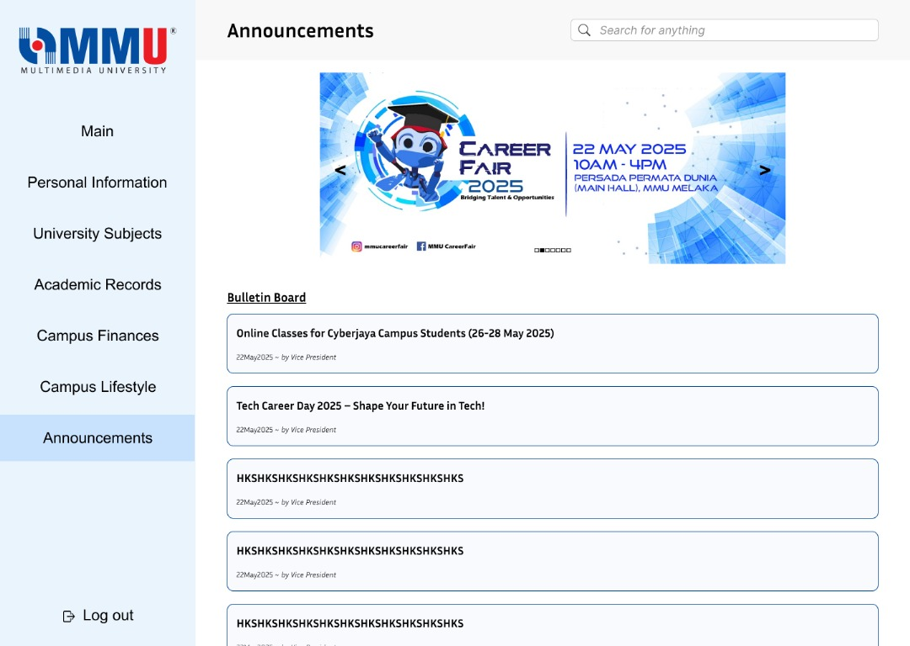

*Figure 41: Student Announcements Page*

## 1.5 Perspective-Based Reading

### 1.5.1 Perspective-Based Reading: Output

Perspective-Based Reading (PBR) was applied to ensure the drafted requirements and scenarios were clear, complete, and relevant from the viewpoint of each major stakeholder. The technique involved reviewing requirement descriptions, mockups, and user stories by role-playing as different users of the system.

The aim was to uncover ambiguities, inconsistencies, or missing functionalities that may not have been evident during initial elicitation or prototyping stages.

Activity details:

* Roles simulated: Student, Lecturer, Parent, Admin
* Reviewers: Internal team members
* Materials reviewed: Draft SRS, questionnaire insights, interview transcript, Figma prototypes
* Review method: Microsoft Word comment tagging + manual checklist for each role

Key Observations from Role-Based Review:

* Student Perspective: Requested longer session durations and easier class schedule access
* Parent Perspective: SMS alerts are important, but notification preferences should be configurable
* Lecturer Perspective: Suggested the ability to bulk upload grades and reuse announcements
* Admin Perspective: Recommended clearer UI for managing classroom bookings and inquiries

Insights from the PBR process led to refinements in the functional requirement section, especially around optional features, role-based visibility, and notification controls.

### 1.5.2 Perspective-Based Reading: Proof of Elicitation

*Table 1: PBR Table*

|  |  |  |  |
| --- | --- | --- | --- |
| **Perspective** | **Section Reviewed** | **Comment/Issue Found** | **Status** |
| Student | Login Flow | "Session times out too fast – no 'Remember Me' option" | Added to SRS |
| Parent | Billing Notification | "Add toggle to turn SMS on/off per parent preference" | Added to SRS |
| Lecturer | Assessment Scheduling | "Need calendar sync with class timetable" | Under review |
| Admin | Booking Approval UI | "No status indicator for pending requests" | Under review |

## 1.6 Summary

To ensure a well-rounded and stakeholder-informed requirement gathering process, five complementary elicitation techniques were employed throughout this project. Each technique contributed uniquely to building a more user-centered and realistic understanding of system needs:

* Brainstorming sessions within the team helped generate the initial feature list and identified assumptions and potential system pain points early in the planning phase.
* A structured interview with a student stakeholder provided deeper insights into real-world frustrations with the current university portal. It also revealed opportunities for enhancing user satisfaction through simple but impactful improvements like persistent login and billing confirmations.
* The questionnaire collected broad feedback from various user roles and allowed us to categorize system features using the Kano model. This enabled feature prioritization based on perceived value, not just frequency of requests.
* Through prototyping, we visualized key student-facing interfaces such as dashboards, timetable, and classroom booking. Early feedback on these mockups helped refine layout decisions and usability before development.
* Finally, Perspective-Based Reading (PBR) allowed team members to simulate different stakeholder viewpoints while reviewing requirements and designs. This helped uncover overlooked needs, gaps in clarity, and role-specific concerns.

# 2.0 Requirements Categorization

## 2.1 Requirements Categorization Table

*Table 2: Requirements Categorization Table*

|  |  |  |  |
| --- | --- | --- | --- |
| **Requirement** | **Kano Category (Prediction)** | **Kano Category (Result)** | **Reason** |
| Student Login Access | Dissatisfier | Dissatisfier | Essential for access; users frustrated without it |
| Two-Factor Authentication | Satisfier | Satisfier | Adds security and builds trust, but not strictly necessary |
| View Grades | Dissatisfier | Dissatisfier | Critical for academic tracking |
| View Timetable | Satisfier | Satisfier | Helps in planning, but not system-breaking |
| View Attendance | Dissatisfier | Dissatisfier | Students and parents expect accurate attendance info |
| View Billing Info | Dissatisfier | Dissatisfier | Transparency on payments is mandatory for students/parents |
| Book Classroom | Satisfier | Satisfier | Adds convenience; not critical but appreciated |
| Approve Classroom Booking (Admin) | Dissatisfier | Dissatisfier | Needed for controlling room usage; failure disrupts flow |
| Upload Materials (Lecturer) | Satisfier | Satisfier | Supports learning; system usable without it but less effective |
| Submit Grades (Lecturer) | Dissatisfier | Dissatisfier | Core academic requirement; delays impact student progress |
| Send Announcements (Lecturer/Admin) | Satisfier | Satisfier | Keeps users informed; important but not system-breaking |
| View Announcements | Satisfier | Satisfier | Users expect regular updates and news |
| Notify via SMS | Delighter | Delighter | Unexpected but highly welcomed; improves awareness |
| Application Tutorial | Satisfier | Satisfier | Eases onboarding, but not essential |
| Accessibility Features | Dissatisfier | Dissatisfier | Required for inclusion; expected by diverse users |
| System Reliability | Dissatisfier | Dissatisfier | Downtime negatively affects trust and usability |
| Longer Sign-In Session | Satisfier | Satisfier | Improves convenience but doesn’t block core functionality |
| Remember Me Login Option | Satisfier | Satisfier | Reduces friction for frequent users |

## 2.2 Analysis

The results from our elicitation techniques, particularly the structured questionnaire and interview feedback, were used to classify each system requirement into Kano categories. This classification helped the team prioritize features based on how strongly they influence user satisfaction.

Overview of Categorization

The requirements were classified into the following categories:

* Dissatisfiers (Must-be Features): 9
* Satisfiers (Performance Features): 8
* Delighters (Attractive Features): 1

Dissatisfiers (Must-be)

These are baseline features that users expect to be present. Their absence leads to frustration, but their presence does not significantly increase satisfaction. In our system, features like Login Access, Attendance Viewing, Billing Info, and Submit Grades fall into this category. These were consistently marked as essential across all stakeholder types (students, parents, lecturers, and admins).

Notably, System Reliability and Accessibility Features were also classified as dissatisfiers, indicating that users view stability and inclusive access as non-negotiable.

Satisfiers (One-Dimensional)

These features directly correlate with satisfaction — the better they perform, the more users are satisfied. Features such as View Timetable, Book Classroom, Upload Materials, and Send Announcements fit into this group.

Several features that improve usability but are not critical, like Two-Factor Authentication, Longer Sign-In Session, and Application Tutorials, were also perceived as satisfiers.

Delighters (Attractive)

Only SMS Notifications was classified as a delighter. While not expected by default, its inclusion generated a strong positive response, particularly from parents and students. This implies that implementing this feature could strongly enhance user satisfaction with relatively low effort.

Key Observations

* Stakeholder variation played a crucial role. While students emphasized dashboard visibility, parents valued notification systems, and lecturers highlighted efficiency in uploading and communicating.
* The dominance of dissatisfiers emphasizes the need to ensure all basic operations are robust and reliable before focusing on innovation.
* No requirements were categorized as “Indifferent” or “Reverse,” indicating that all proposed features have at least some value to the users surveyed.

# 3.0 Conclusion

The Kano analysis confirms that to meet baseline expectations, the team must focus on implementing all dissatisfiers as a minimum viable product. Satisfiers should be optimized for performance, while delighters like SMS alerts can be strategically used to boost engagement and satisfaction. This structured prioritization will allow better allocation of development time and resources based on user-centered value.

# Change Log Table

|  |  |  |  |
| --- | --- | --- | --- |
| Version | Date | Author | Changes Made |
| v1.0 | 23 May 2025 | Teoh Xuan Xuan | Added project cover page; created version history log table |
| v1.1 | 24 May 2025 | Teoh Xuan Xuan | Update Project Title and Table of Content |
| v1.2 | 25 May 2025 | Yang Jia En | Changed table of contents, added contents |
| v1.3 | 25 May 2025 | Teoh Xuan Xuan | Check alignment, header and etc. |